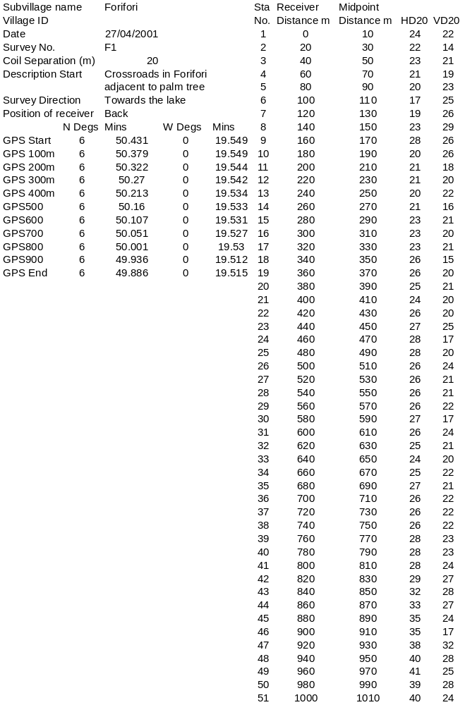

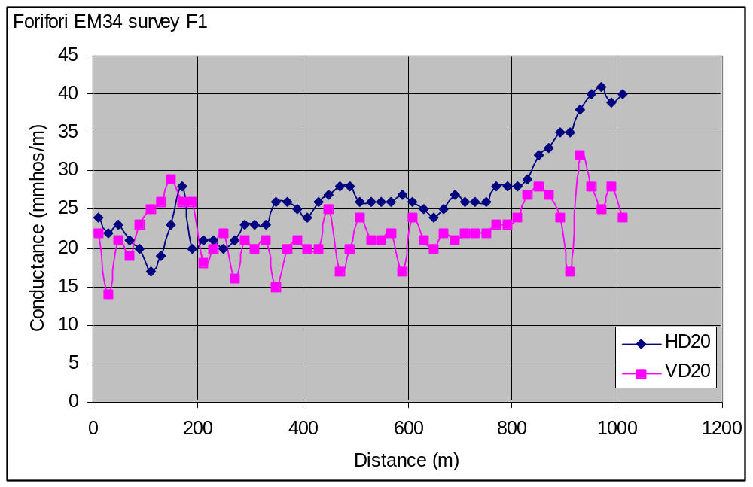

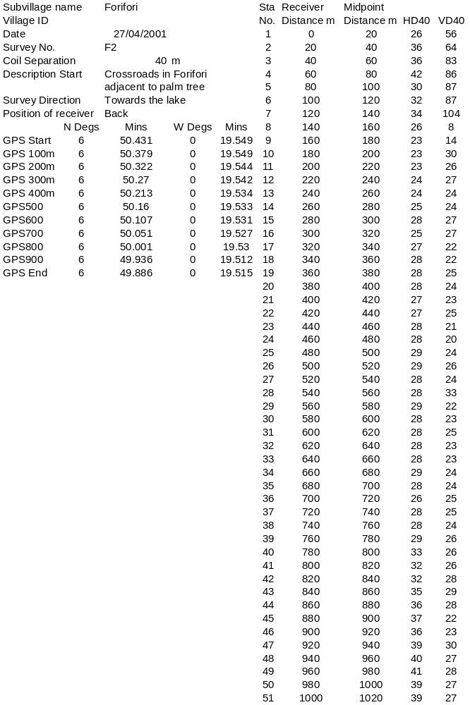

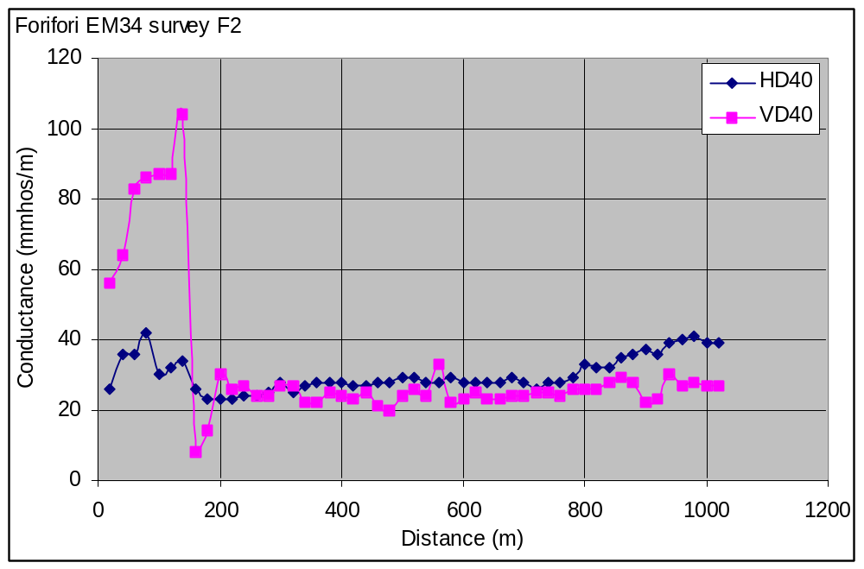

Subvillage name |  | Forifori |  | GPS Start | 6 | 50.184 | 0 | 19.249
Village ID |  |  |  | GPS 60m | 6 | 50.212 | 0 | 19.218
Date |  | 27/04/2001
Survey No. |  | f3
Coil Separation |  | 20 | m
Description Start |  | Close to proposed drill site for deep well, near the 3 existing wells.
Survey Direction
Position of receiver |  | Back
Station | Receiver | Midpoint
No. | Distance m | Distance m | HD | VD | Comments
1 | 0 | 10 | 39.1 | 16.2 | No houses or power lines in this area.
2 | 20 | 30 | 35.7 | 26.5 | Adjacent to existing borehole
3 | 40 | 50 | 36.4 | 20.5 | crossing small stream
4 | 60 | 70 | 31 | 25.7 | way forward blocked by forest
Subvillage name |  | Forifori |  | GPS Start | 6 | 50.184 | 0 | 19.249
Village ID |  |  |  | GPS 80m | 6 | 50.149 | 0 | 19.272
Date |  | 27/04/2001
Survey No. |  | f4
Coil Separation (m) |  | 20
Description Start |  | Close to proposed drill site for deep well, near the 3 existing wells.
Survey Direction
Position of receiver |  | Back
Station | Receiver | Midpoint
No. | Distance m | Distance m | HD | VD | Comments
1 | 0 | 20 | 37.8 |  | landrover parked nearby
2 | 20 | 40 | 21.6
3 | 40 | 60 | 16
4 | 60 | 80 | 13.1 |  | ferricrete outcropping
5 | 80 | 100 | 13.8 |  | way forward blocked by thick bush

Subvillage name |  | Forifori |  | GPS Start | 6 | 50.149 | 0 | 19.272
Village ID |  |  |  | GPS100m | 6 | 50.134 | 0 | 19.217
Date |  | 27/04/2001
Survey No. |  | f5
Coil Separation (m) |  | 20
Description Start |  | End of traverse f4
Survey Direction
Position of receiver |  | Back
Station | Receiver | Midpoint
No. | Distance m | Distance m | HD | VD | Comments
1 | 0 | 10 | 15.5 | 12.1 | No houses or power lines in this area
2 | 20 | 30 | 16.6 | 14.1
3 | 40 | 50 | 16.4 | 15.7
4 | 60 | 70 | 22.6 | 15.4
5 | 80 | 90 | 26.8 | 6.1 | boggy waterlogged ground
6 | 100 | 110 | 28.2 | 16
Subvillage name |  | Forifori |  | GPS Start | 6 | 50.149 | 0 | 19.272
Village ID |  |  |  | GPS100m | 6 | 50.185 | 0 | 19.319
Date |  | 27/04/2001
Survey No. |  | f6
Coil Separation |  | 20 | m
Description Start |  | End of traverse f4
Survey Direction
Position of receiver |  | Back
Station | Receiver | Midpoint
No. | Distance m | Distance m | HD | VD | Comments
1 | 0 | 10 | 13.4 | 13.3
2 | 20 | 30 | 13.1 | 12.7 | dry ground now on
3 | 40 | 50 | 12.7 | 12.9 | small ferricrete outcrop
4 | 60 | 70 | 12.4 | 12.8
5 | 80 | 90 | 13.5 | 13.1
6 | 100 | 110 | 14.1 | 12.8

